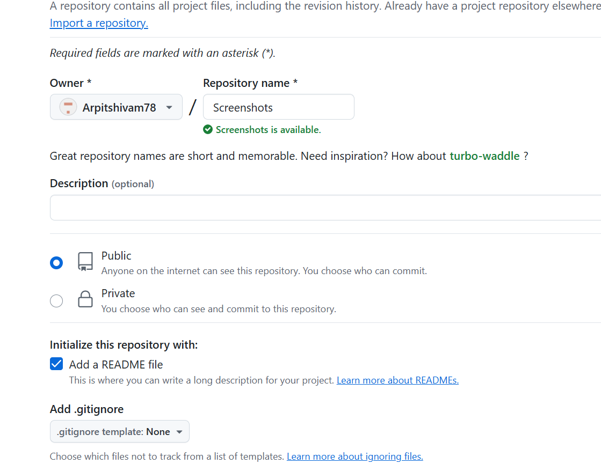

Step 1:- Create a repository

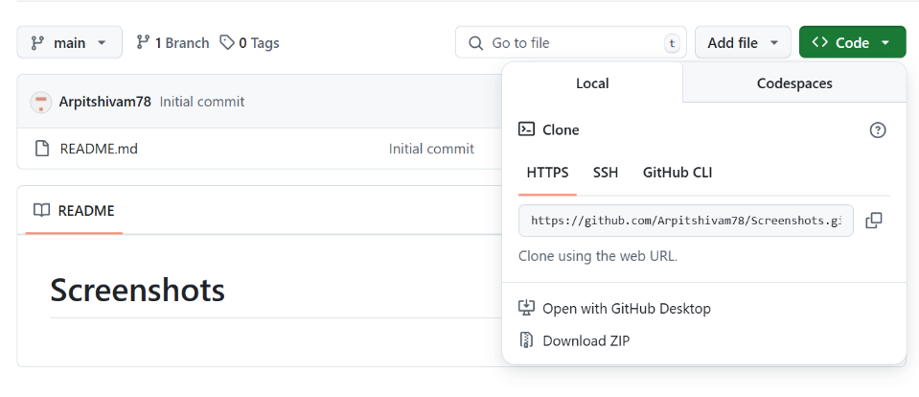

Step 2 :- Copy the Link

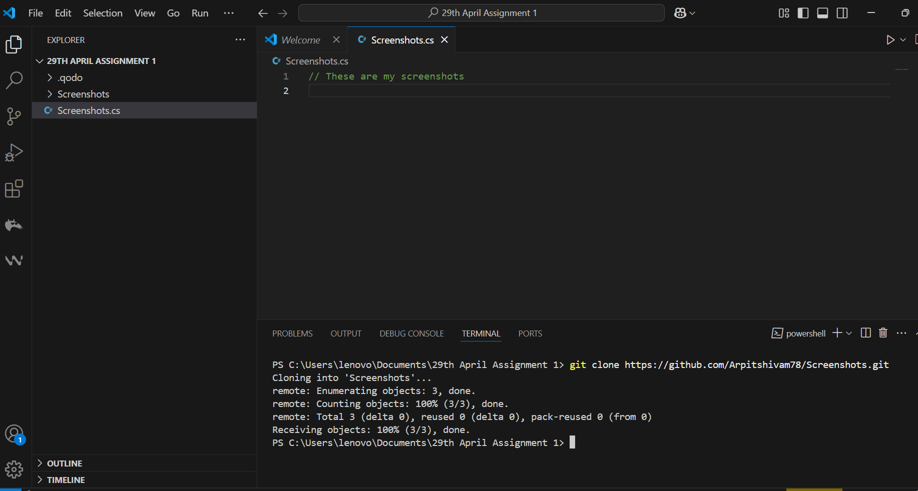

Step 3 :- Paste the git repo link in vs code using the command git clone



Step 4 :- Change the Directory using command cd

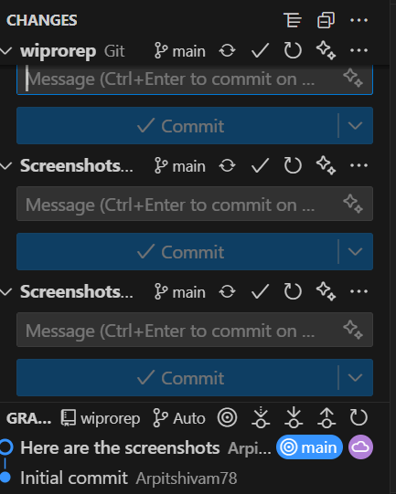

Step 5 : - Commit and push to commit to git.

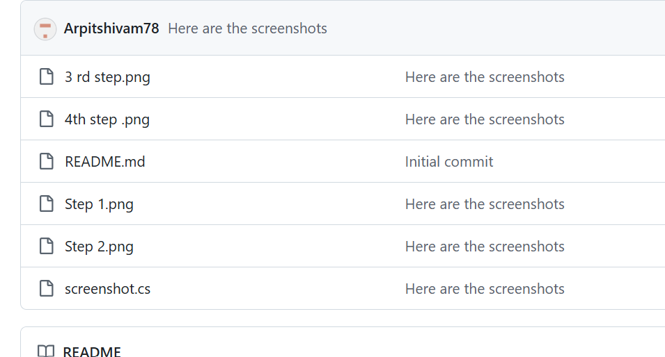

Step 6 : - Uploaded